

**Analytics of Love**

**Tinder is a geosocial networking and online dating application that allows users to anonymously swipe to like or dislike other profiles based on their photos, a small bio, and common interests. Once two users have “matched” they can exchange messages.**



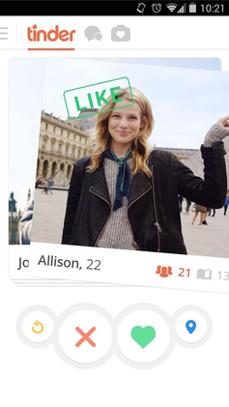

-By

**Shivam Kumar Giri**

**PROBLEM STATEMENT**

**Analyze the machine learning and data science techniques that Tinder uses to show you the perfect match:**

**Your analysis will include:**

1. **An understanding of data points Tinder collects about each user**
2. **What data science or machine learning techniques are being used to predict your next match?**
3. **What other data points do you think Tinder should consider for even a better match? What techniques will you suggest to improve the match making?**

**ABSTRACT**

**Tinder is an app has around 100M+ users, 10M of which use the app daily. Since 2012, there have been over 30B+ matches on Tinder, a total of 2B+ swipes occur every day on the app and an estimated 2M+ dates occur per Week with this the app.**

**Here we tend to analyze the Machine Learning prospects of Tinder which make tinder rises to millions of users and better than other Dating Platforms**

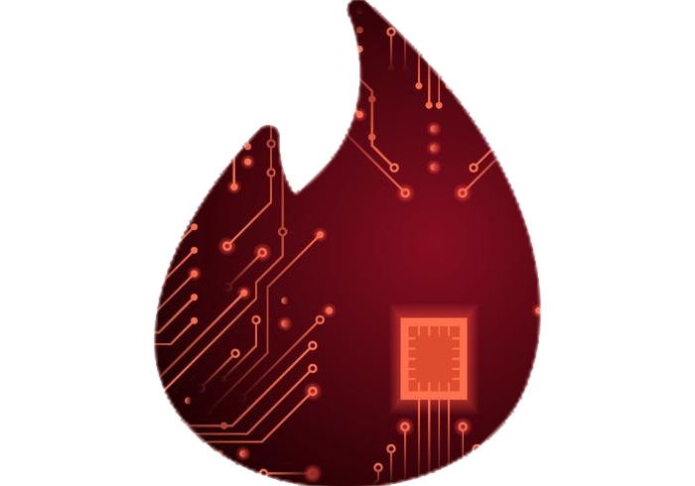

**DATA POINTS COLLECTED BY TINDER**

**General Data Collected**

1. **User Mail id**
2. **App Installation Date**
3. **Information of phone platform**
4. **App version**

**Data Collected for machine Learning Prospects**

* **User Geographic Location**
* **Age Registered**
* **User Gender and Sexual Preference**
* **Successful Matches**
* **Time Spent by Users on the App**
* **Behavioral Analysis of user in the Swiping.**
* **Behavioral Analysis of user in the Conversation**
* **Types of people right swiped**
* **Analysis of type of status**
* **Expectations of users by Behaviors**
* **No of messages Sent**
* **User Preferences for Dating**
* **General Interests of users such as hobbies etc.**
* **Gender and Age**
* **Types of Profile Super Likes Given**
* **Total Swipe Activity (Both Right and Left Swipes)**
* **No of Super likes Given and received by User**
* **User Feedback**
* **Length of message Given**
* **Types and number of emojis used**
* **Times pent in successive swipes**

**ALGORITHMIC TECHNIQUE USED BY TINDER**

* **Tinder uses data collected by various algorithms and user’s behavior over Tinder to create an exception matching system using Predictive analysis which in turn uses the Supervised Learning.**

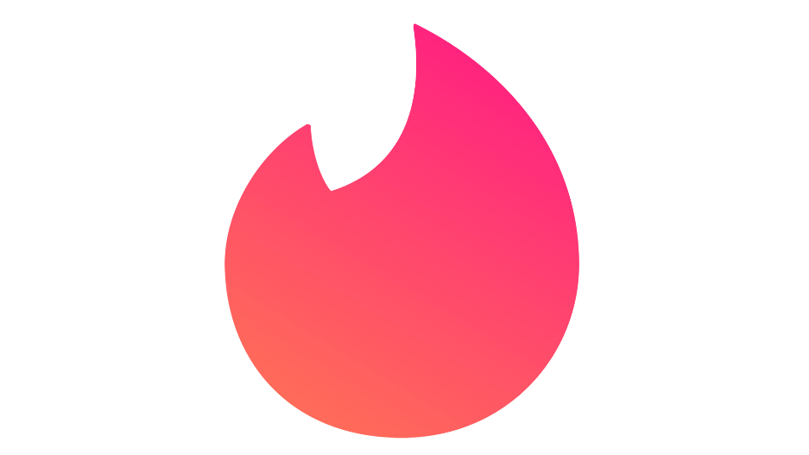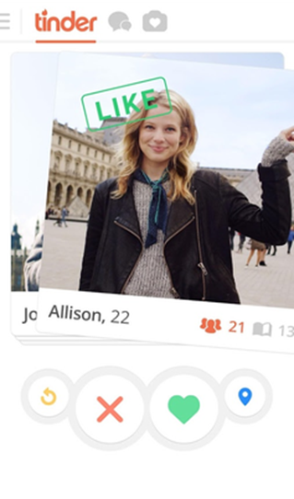

* **Tinder Uses Computer Visioning and Deep Learning to recognize Facial Expressions, Facial Complexations, Hairstyles, eye and other stuffs to get more User Specifics Profile After the Analyzing Users Swipes.**

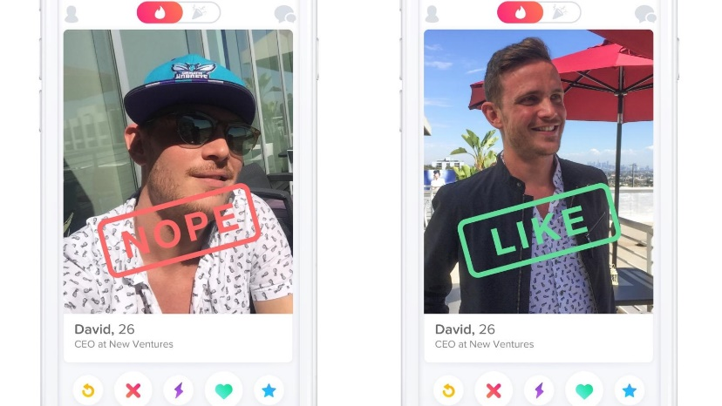 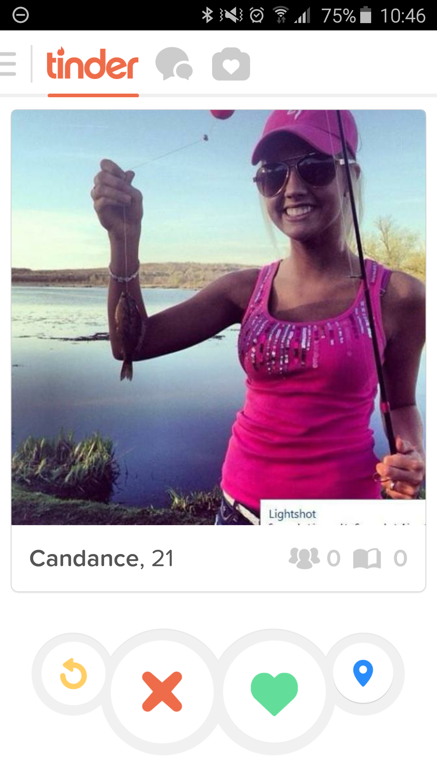

* **Sentiment Analysis by User Rating, Reviews, Location, Status, and other Posts, which in turn help tinder to gain more about Emotions and other Behaviors.**

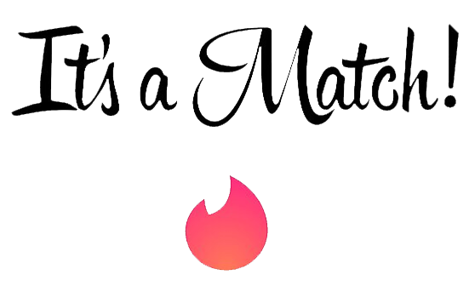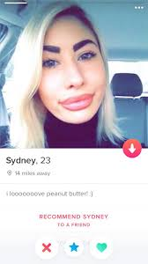

* **Tinder uses reinforcement learning to create a user specific content, suppose a user generally right swipe a person with Army Hair styles, and generally Super likes the profile with Display Picture clicked with the puppies and generally in a dark background, Tinder tends to show profile mostly with the expected out comes.**

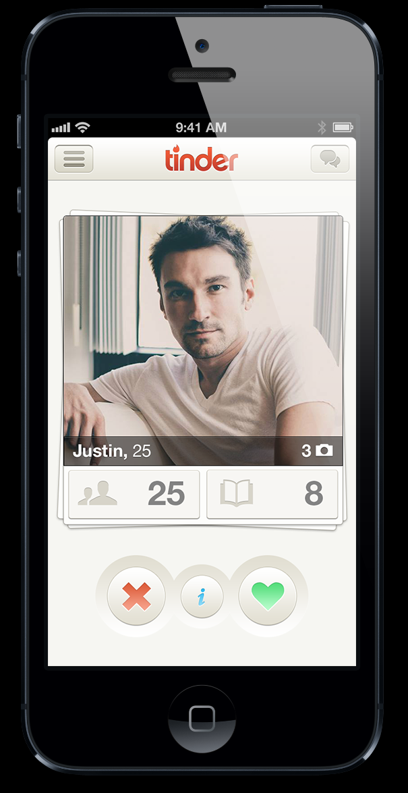

* **Tinder uses Linear Regression that help us determine how a particular variable may determine the right swipes or super likes of a person for example we can find a relation between job profile of user and the no of right swipes or super likes given for various jobs. For Example, using Linear Regression we can determine that a particular user has right swiped the profiles having jobs as Software Engineering with Machine Learning.**

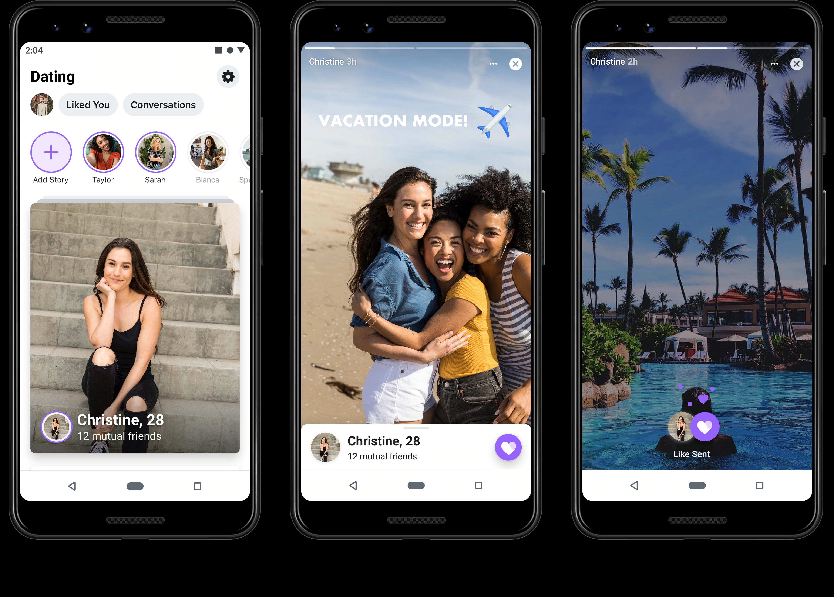

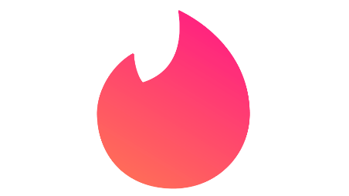**IMPROVEMENT OF TINDER**

**According to me Tinder can Improve by:**

* **Clustering of data: Better clustering of data can help the user to sort profiles better like search by job, search by locations etc.**
* **Using Discriminant Analysis to Understand Human Behavior more as most of the user fake or create wrong data in Profile**
* **Adding more Factors for swipes such as religion etc.**
* **Add a preference for best meetup location such as cafes for better dates and use Ann and data points of nearest cafes.**
* **Blocking users with more explicit contents/fake contents.**
* **Also adding the preference of other genders such as LGBT etc.**
* 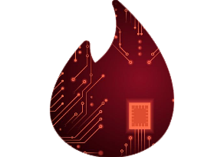**Create a feedback rating of Profiles/ Users**

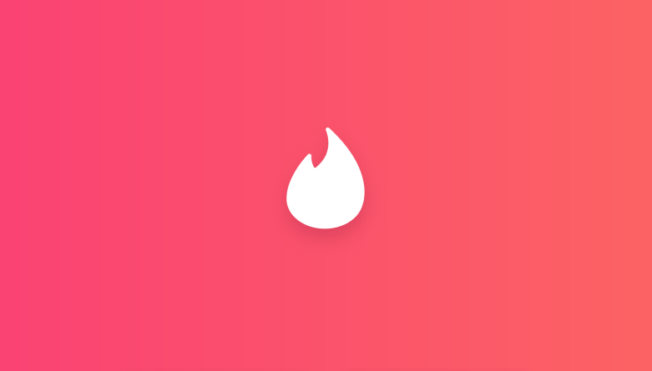**CONCLUSION**

**Tinder, a dating site for lovers and an awesome learning experience for machine learning enthusiasts. Tinder always looking for ways to integrate technology to make the experience better for its users. Also the tinder serves a s a better Business need.**

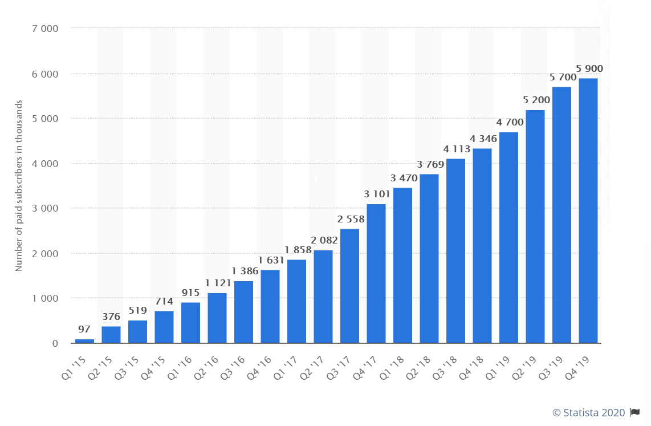

**THE END**